**Ideation Phase**

**Brainstorm & Idea Prioritization Template**

|  |  |
| --- | --- |
| Date | 19 September 2022 |
| Team ID | **PNT2022TMID38414** |
| Project Name | Intelligent Vehicle Damage Assessment and Cost Estimator for Insurance Companies |
| Maximum Marks | 4 Marks |

**Step-1: Team Gathering, Collaboration and Select the Problem Statement**

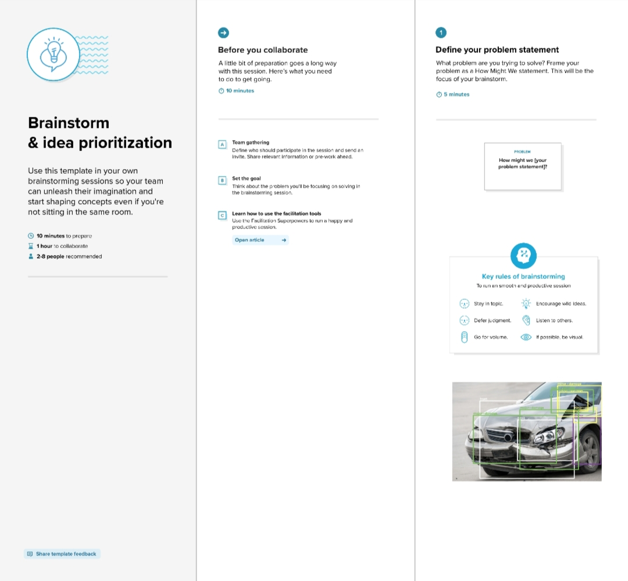

**Step-2: Brainstorm, Idea Listing and Grouping**

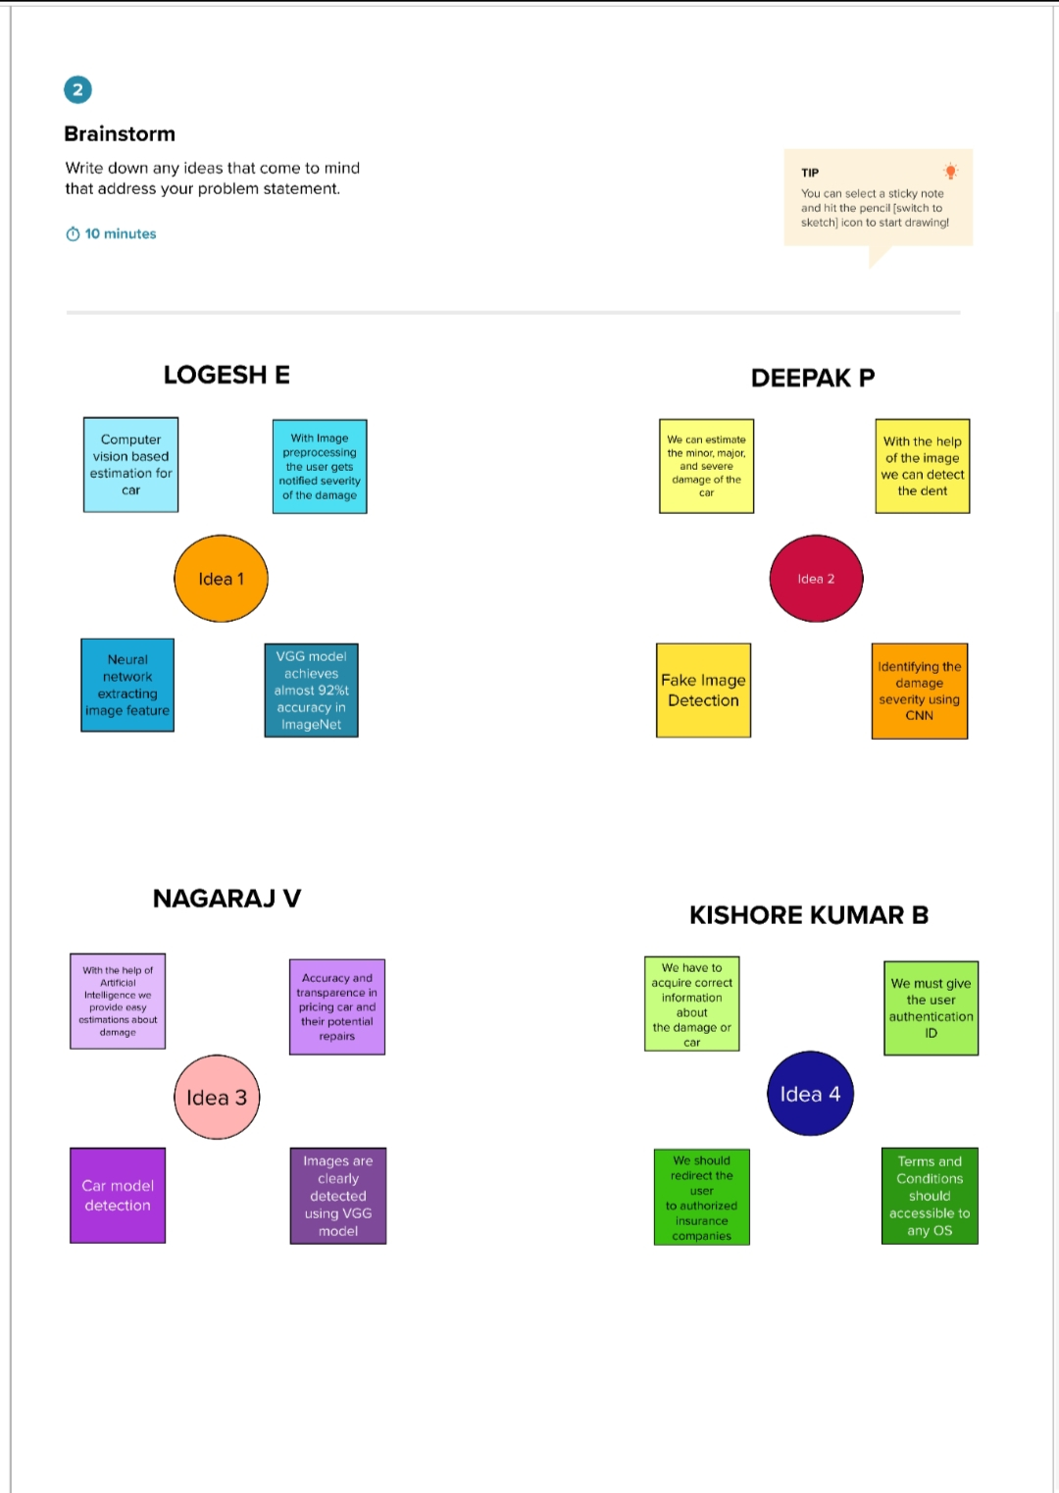

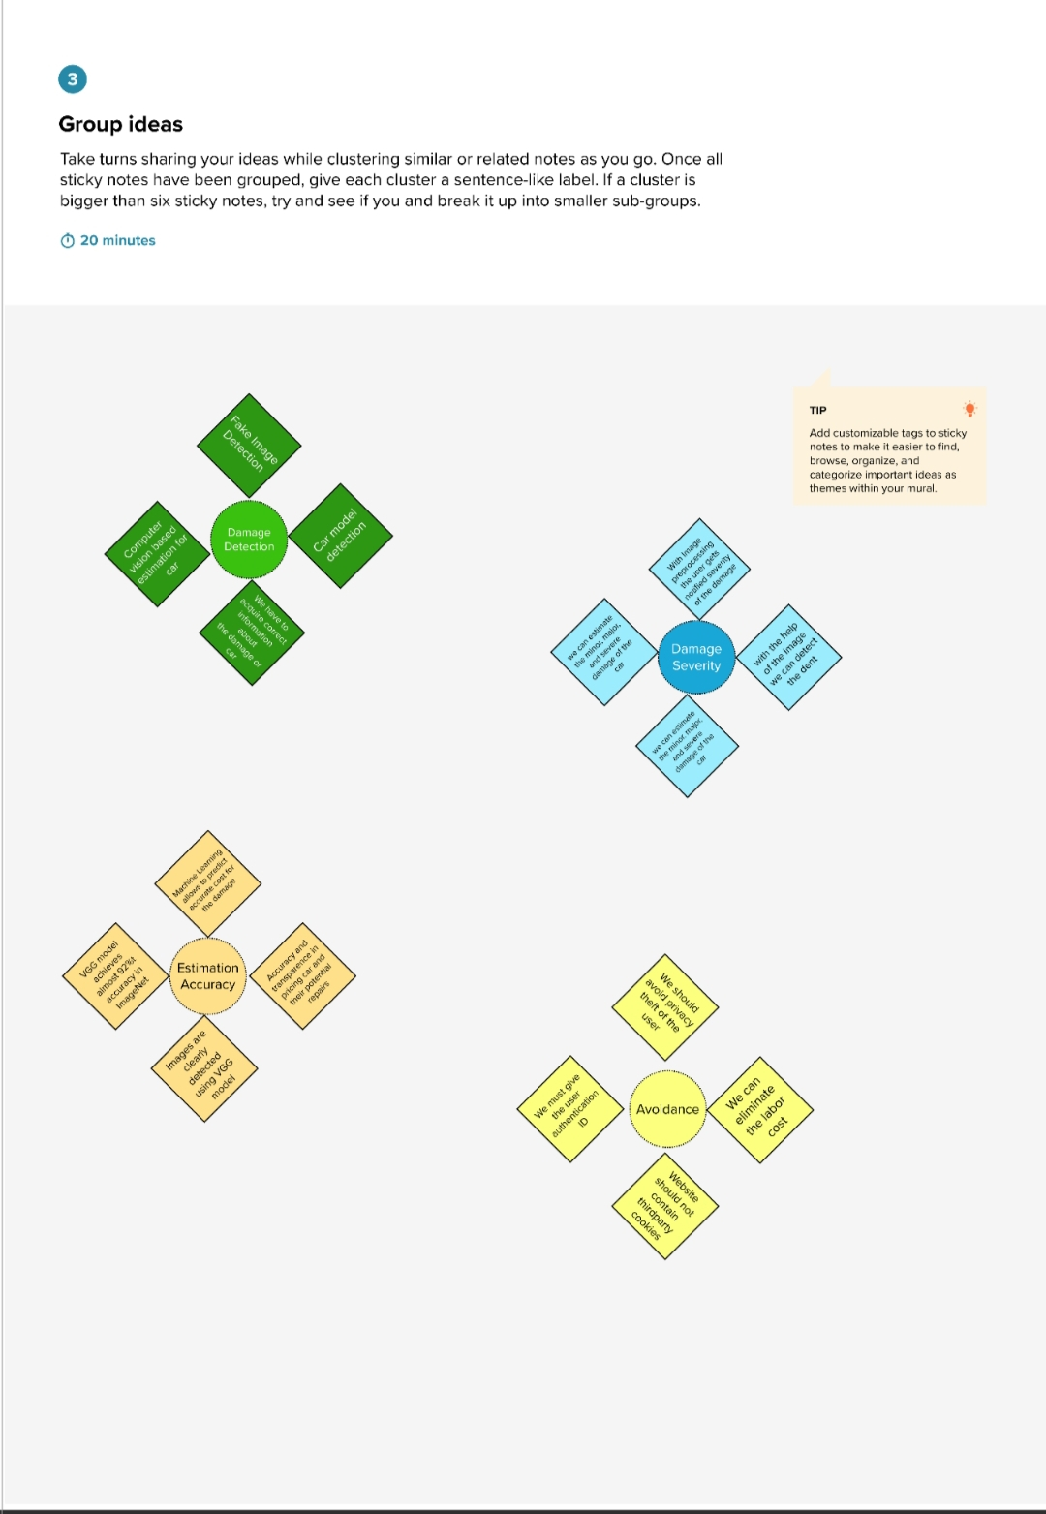

**Step-3: Idea Prioritization**

